**IMPLEMENTATION DOCUMENTATION**

**Hardware Requirements:**

1. Processor: i3, i5, i7 processor
2. RAM: 4GB+
3. Hard Disk: 20GB+

**Software Requirements:**

1. Operating System : Windows 8 and above
2. Frontend Technology : Html, CSS, Bootstrap, Java Script
3. Backend Technology : Python(https://www.python.org/downloads/)
4. Framework : Django
5. Database : Mysql(https://www.mysql.com/downloads/)
6. IDE : VS Code(https://code.visualstudio.com/download)

**Steps of implementation:**

1. Modules should be installed in python:
   * 
   * 
   * 
   * 
   * 
   * 
2. Download the Q_projects.zip file which is attached along with this document.
3. Unzip the file in the desired location
4. Open Q_projects folder with VS Code.
5. Open settings.py file and enter your database credentials in DATABASE block and create the database in Mysql with name mentioned in settings.py.
   * CREATE DATABASE quality;

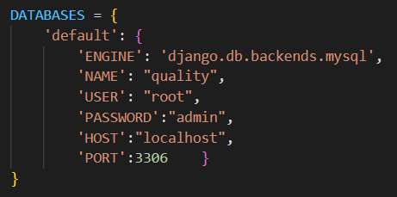

1. Run Make migrations:



1. Run migrate to create tables in database using models.py.



1. Add login details into table named “q_app_logindetails” with designations as “superadmin” for Super admin and “user” for User using command given below
   * insert into q_app_logindetails values(id, username, password, role, mail);
2. Enter runserver command to start the app.



1. After hitting above commands, web application is deployed using Django and URL displayed in the terminal.

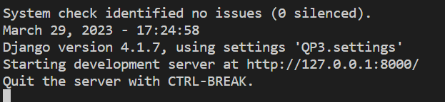

1. Open the URL in browser and the web application runs in browser.
2. Username and password for Superadmin and user are given below:
   * Username: superadmin, password: super.
   * Username: user, password: user.